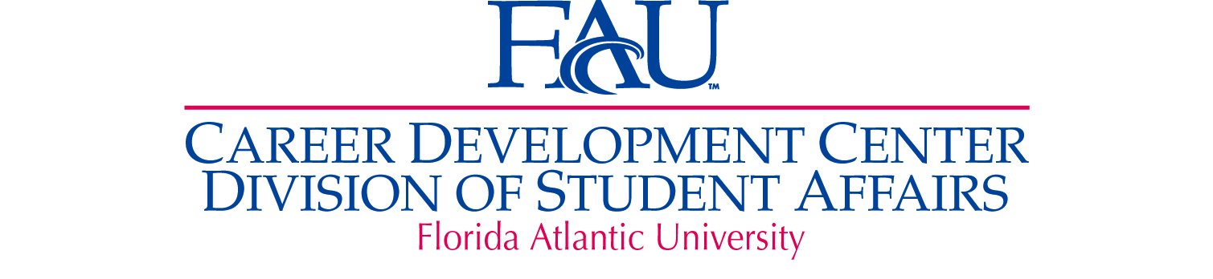

Career Destination Survey Development Timeline

Outcome #2

**Period #2, 2010-2011**

6/20/11 Met with Dr. Brown to recommend administering the Career Destination Survey at upcoming commencement.

Presented draft version. Was asked to get feedback from Dr. Rosson.

6/27/11 Met with Dr. Rosson of the Graduate College for feedback.

**Period #3, 2011-2012**

7/20/11 Joint meeting with Dr. Brown (Sr. VP Student Affairs), Dr. Rosson (VP Research/Dean of Graduate College), and Dr.

Kaul (VP for Strategic Planning and Assessment) to review survey and discuss how it would be administered at

graduation.

7/22/11 Final review of survey with Dr. Rosson.

8/4/11 Met with Registrar.

8/5/11 Met with Dr. Brown and presented process to pilot survey.

8/9/11 Piloted survey at graduation.

8/18/11 Met with Institutional Effectiveness and Analysis to analyze data.

9/2/11 Created draft of August 2011 Summary Report.

11/4/11 Met with Institutional Effectiveness and Analysis to discuss survey modification to scantron.

12/8 & 12/9/11 Administered survey at graduation ceremonies.

2/8/12 Met with Institutional Effectiveness and Analysis to begin data analysis.

2/22/12 Created draft of December 2011 Summary Report.

2/28/12 Met with Institutional Effectiveness and Analysis to revise survey and print in two colors.

3/19/12 Received final approval of revised survey from Dr. Brown.

5/3 & 5/4/12 Administered survey at graduation